Time-dependent probability Markov modelling in R

In this part you will practice to include time-dependent probabilities in to your Markov model. You can do this using your own model from last workshop (Sick-sicker model), or by using the default Markov using the Healthy-Sick-Dead states. Just like the previous Markov model, you have to build a transition matrix that describe the probability from moving from one health state to another health state. When you want to include time-dependent probabilities you have to convert your matrix (2 dimensional) to an array (3 dimensional).

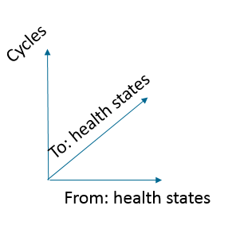
Good luck!
- Create a new “probability to die when sick” (p.HD) that varies over time, with a maximum of the number of cycles (you can use the seq function to create an linear increasing probability: seq(0.003, 0.01, length.out = number of cycles)
- Instead of creating an transition probability matrix, build an array with correct dimensions (dim = c(n.s, n.s, n.t), dimnames = list(v.n, v.n, 0:(n.t-1)))
- Fill the transition matrix, but leave an extra comma after the naming of the states
( a.P[“Healthy, “Healthy”, ] <- 1 – p.HD – p.HS )
- Check if the array is correct (just print a.P in the console)
- Run the Markov model by multiplying the initial Markov trace with the transition probability array
m.TR[t + 1 , ] < - m.TR[t,] %*% a.P[ , , t]
- Optional: plot the markov trace and overall survival

